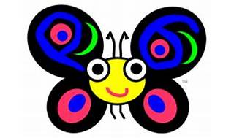



Explore

**Raku**, formerly known as **Perl 6**, is a member of the Perl family of programming languages. [It introduces elements from various modern and historical languages, making it expressive and feature-rich1](https://en.wikipedia.org/wiki/Raku_%28programming_language%29). Here’s a brief overview of Raku:

* [**Expressive and Feature-Rich**: Raku offers functional programming primitives, lazy and eager list evaluation, junctions, autothreading, hyperoperators (vector operators), parallelism, concurrency, and asynchrony, including multi-core support](https://en.wikipedia.org/wiki/Raku_%28programming_language%29)[2](https://raku.org/).
* [**Definable Grammars**: You can create custom grammars for pattern matching and generalized string processing](https://en.wikipedia.org/wiki/Raku_%28programming_language%29)[2](https://raku.org/).
* [**Optional and Gradual Typing**: Raku allows you to gradually introduce type annotations to your code](https://en.wikipedia.org/wiki/Raku_%28programming_language%29)[2](https://raku.org/).

To start learning Raku, follow these free resources:

1. [**Raku Programming Language Homepage**](https://raku.org/): Explore documentation and get started with Raku.
2. [**Raku Modules Directory**](https://raku.org/getting-started/): Use the **zef** module manager (included with Rakudo Star) to install available modules.
3. Write your first Raku program.
4. Write another program in Raku.
5. Get involved in the Raku community and contribute to this vibrant language! ☺